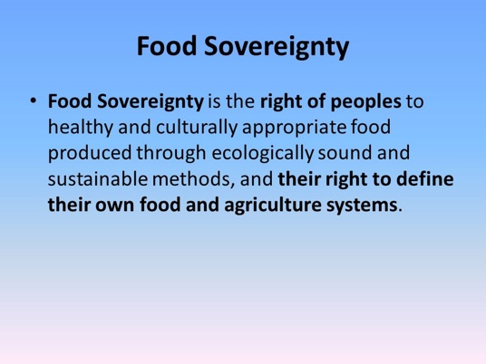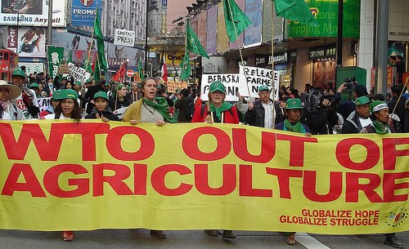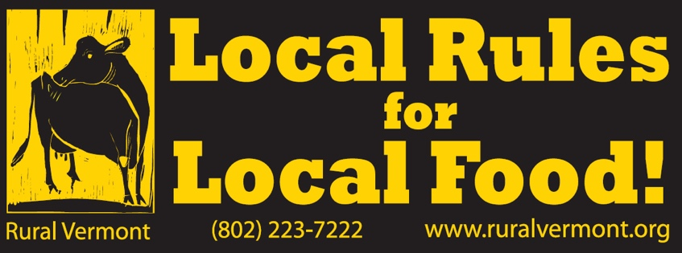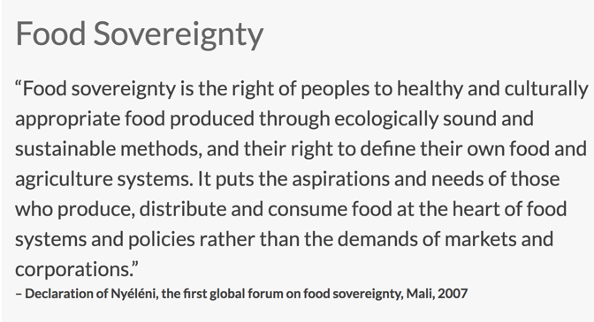

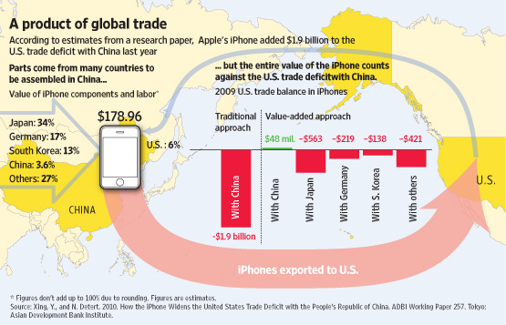

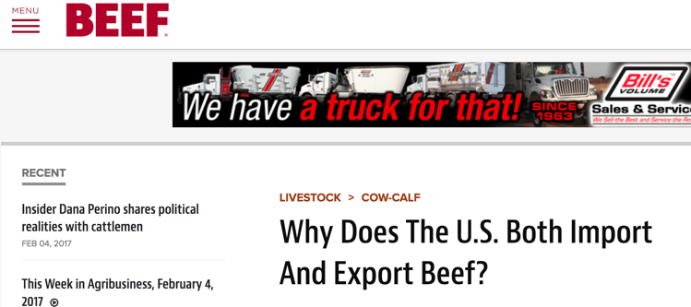

Why Does The U.S. Both Import And Export Beef?
The job of markets is to seek out the highest value for products produced and encourage the most efficient use of resources to facilitate that production, says Derrell Peel, Oklahoma State University (OSU) Extension livestock marketing specialist.
Jun 11, 2010
…
One of many complexities that make the beef industry so challenging is the fact that the set of animals processed into meat results in a vast array of different products of different qualities. The set of products produced does not, in general, exactly match the preferences of domestic consumers. For instance, U.S. beef demand largely consists of demand for ground beef and steaks. Ground beef can, of course, be made from a wide variety of qualities of lean but steak demand is mostly oriented towards high-quality middle meat cuts.
… Thus, the export of things like Select chucks and rounds to Mexico is very complimentary to the U.S. market … The import side seems harder to understand but it mostly relates to the hamburger market. Ground beef production requires much additional lean to mix with the trim resulting from steer and heifer slaughter in order to make ground beef … It’s not very efficient to feed cattle to higher quality and then grind the meat back into hamburger. This is particularly true when we can sell the meat in an export market. Even at a relatively low value as a muscle cut, these products have a higher value for export than for grinding.

